Ecosystem Services Valuation Database (ESVD) version December 2020: overview of summary statistics

by Stefanos Solomonides (stefanos.solomindes@fsd.nl), as output from a short desk study funded by FAO (September – December 2020). For further information on this project, and the further development of the Ecosystem Services Data Base (ESVD): www.es-partnership/org/esvd
- . -
The current version of ESVD now contains 4,820 value records based on 955 studies. The number of value estimates that could be standardised to Int.$/ha/year for all relevant beneficiaries at 2020 price level is 2,446 (for the value standardisation process, refer to the ESVD report, 2020, downloadable from www.es-partnership/esvd ). These values are based on studies that have only 1 biome and 1 service and were not estimated using the Value Transfer method. For estimating the mean values per ecosystem service for each biome, 5% of high and low outliers were excluded (on a per biome/service level). The distribution of standardised records across different biomes is presented in Figure 1. The summary statistics table is presented in Table 1.

Figure 1 Number of standardised values per biome.
Note that these summary values are intended for illustration only and to identify data gaps. These summary statistics do not reflect the underlying ecological and socio-economic contexts of the diverse study sites from which the data was collected. For the purposes of value transfer, users are advised to select value estimates from the database that match the characteristics of their policy site(s) since values are time and context dependent.
Mean values (and thus total biome/service values) are influenced by the amount of the standardised values, as well as significant data variation for each biome per service category. In the standardised dataset, there were individual cases where very few estimates skewed the total value either upwards or downwards. The effect of outliers has been stronger on biome/service combinations with very few standardised values (e.g. <5) because winsorizing 5% of extreme outliers had negligible influence on the mean value. Therefore, to control for such factors, we treated the standardised data very carefully. For example, we did not include in the summary table the value for biomes that had less than 5 standardised values for a service (this explains a lot of the missing values in the current table). For the remaining values, we first sorted the standardised values for each biome/service combination from low to high. Then, the lowest and highest values were ignored from the dataset. Finally, an average was calculated after excluding 2.5% top and 2.5% bottom outliers. The only exceptions in which we manually controlled the data for estimating the summary average was: Maintenance of genetic diversity and Maintenance of life cycles for Coastal systems (incl. wetlands) and Rivers & Lakes respectively. For these 2 services, instead of excluding 1 value from the bottom and 1 from the top, we excluded 2 values only from the top (comparatively, the low values were not outliers). We did that because the top 2 values skewed the average significantly and the 5% exclusion did not have much effect, due to the small number of available records. Thus, manually controlling for these services was deemed necessary.
Social value of biodiversity indicator: the standardised mean values will be used in the B-INTACT tool for estimating the social cost of biodiversity (this is only one out of several indicators used in the tool). The sum of the mean standardised values is set to represent the ‘default’ Ecosystem Service value of each land patch (ESVD biome classification is matched with the FAO Global Ecological Zones, for the exact matching check the updated version of the B-INTACT user guidelines). The adjusted indicator is an attempt to capture economic benefits (or losses) associated with the impacts of projects on ecosystems and biodiversity. Despite the limitations of the current application (e.g. illustrative purpose of standardised mean values, data variation, data gaps etc), it serves as a starting point for providing more accurate, context specific ES values for each project assessment. Current and future developments of the ESVD are expected to provide the technical means for improved integration in B-INTACT. The ongoing and planned technical upgrade of the excel database in an online interactive platform will allow for:
- Geo-positioning of value estimates.
- Search, selection and visualisation of records.
- Automatization of summary statistics on the standardised values of these records (mean, median, minimum, maximum Int$/ha/year).
- Further addition and review of data on different biomes and services.
The improved functionalities are very promising regarding the ESVD integration in the B-INTACT tool, since it will be possible to match relevant data with the information given by the user in a faster and more accurate way (e.g. geolocation, automatization of standardisation and statistical analysis). Moreover, on-going research and addition of new data is expected to provide information for the current data gaps. Potential pathways for improved integration of the ESVD in B-INTACT should be explored further.

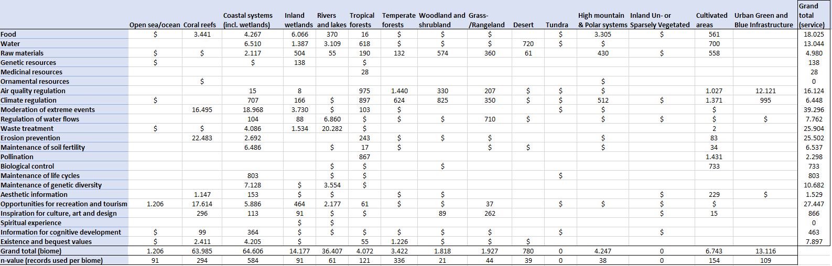
¹ The values are means for services that had at least 5 records, discarding the highest and lowest values and then remaining values were winzorized at 2,5% high and low values before calculating the mean. This meant that 463 values were discarded (out of 2,446 values standardised).
Table 1: Summary statistics table of ESVD v. January 2021 - mean standardised values per service for each biome in $2020/ha/yr for all beneficiaries (based on 1983 value records¹).
Dollar signs indicate services for which standardised values exist in ESVD but have less than 5 records.

